Microsoft Excel 2010 Settings

Step 1 Disable Macros
Open a new Excel Spreadsheet
Click “File” tab on upper left corner
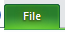
Click “Options” at the bottom left
Click “Trust Center” on the left menu
Click “Trust Center Settings” button
Click “Macro Settings”
Check “Disable all macros with notification”
Click “Add-Ins” on the left menu
Check “Require applications Add-ins to be signed by Trusted Publisher”
Click “External Content” on the left menu
Click “Prompt user about Data Connections”
Click “OK”
Click “OK”

Step 2 Select “Add-Ins”
Open a new Excel Spreadsheet
Click “File” tab on upper left corner
Click “Options” at the bottom
Click “Add-Ins” on the left menu
Click “Go” 
Check “Analysis ToolPak”
Check “Analysis ToolPak VBA”
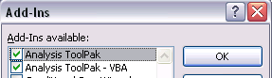
Click “OK”
This box may pop up, if not, move to Step 3
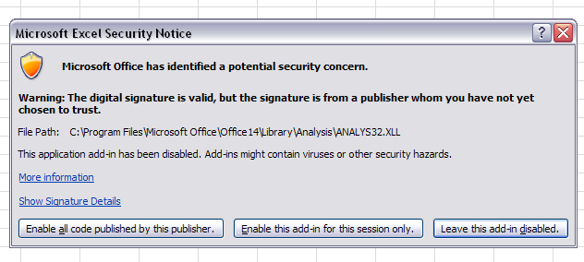
Choose “enable all code published by this publisher”
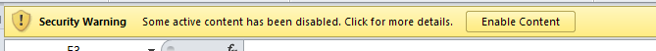
Click “enable content”

Step 3 Verify REPT database is setup on PC
Click the Microsoft Office Button (bottom left corner)

Click Control Panel
Click (view by) Category
Click Small Icons
Click Administrative Tools
Double Click Data Sources (ODBC)
Click 1st tab (User DSN)
“REPT” should be listed, if not listed
Request “REPT” installation at the ITCS Helpdesk https://ithelp.ecu.edu/Default.asp
Click ok
Close out of Admin Tools

Step 4 Remove check beside “Reuse windows for launching ……”
Click the Microsoft Office Button (bottom left corner)
Click Control Panel
Click (view by) Category
Click Small Icons
Click Internet Options
Click Advance Tab
Scroll down to Browsing
NO CHECK beside “Reuse windows for launching shortcuts”
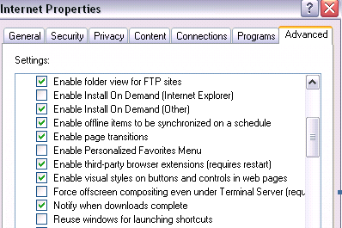

Click OK
Shut down PC and restart

