**Fixed Assets Inquiry and Annual Inventory Reports Lookup**

On an annual basis, Fixed Assets will disseminate two reports to meet annual equipment

inventory verification requirements. Each department is responsible for verifying

information for their inventory and reporting any changes or corrections to the Fixed Assets

office. Fixed Assets will post the following inventory reports on the e~Print system on

October 1st of each year.

FYYF139 Inventory Verification List

FYRF135 Missing Inventory List

To view these reports in e~Print, permission must be granted via the Banner Security

Request Form. This permission will also allow the end user to view individual assets in

Internet Native Banner (INB).

                To gain access to those e~print reports, you would need to update your Banner Finance Security Request. Go to Pirate Port and open Banner Security. Click on the word Finance. You’ll need to update your Fixed Assets role (see snapshot). Please make sure to select your ORG at the bottom of the screen.  Don’t change any of your other access (if you have any) or else it will override what you have in the system. Once you have updated your Fixed Assets access, click submit on the pop up and ALSO on the main finance screen. Once you do so, you will have two pop up messages to agree to. Once your security has been granted, you will receive a system generated email and will then be able to access those e~print reports.

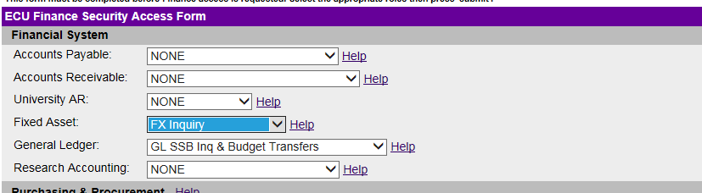

Once you have been granted permission to access these e~Print reports, your password is the

same as your password for Internet Native Banner (INB). If your password has expired or

needs changing, this will need to be updated via INB.

**Instructions for e~Print Users**

• Go to Systems Coordination Webpage <https://financialservices.ecu.edu/systems-coordination/>

• Click the Finance User Logins Button in the sidebar

• Click ePrint Login

• Log in using your ECU User ID (pirateID) and INB Password

From the Repository drop down select: Banner Finance

• Using the dropdown box located at the bottom of the screen,

Select FYYF139 – Inventory Verification List

Select FYRF135 – Lost Inventory (all departments do not have this report)

• Click on **PDF**

• On the left, Scroll Down to find your organization(s)

• Select the **ORGN** numbers for your department(s)

If the FYYF139 or FYRF135 reports are not listed, please contact Financial Services Liaison at Systems Coordination for assistance.

* Contact Laura Williams Fixed Assets Coordinator at 328-9931 or [williamsl@ecu.edu](mailto:williamsl@ecu.edu) for assistance.

**Instructions for INB Users (this is optional)**

• INB users may view individual assets under their department that have been recorded

in the Fixed Assets System

• Log into **Production Internet Native Banner**

(Note: you must have a completed, approved Banner Security Request Form with

Fixed Assets Inquiry before access is granted)

• Double click on the **Finance System Menu**

• Double click on **Fixed Assets**

• Select **Fixed Asset Master Query (FFIMAST)** (Note: you can only view inventory for ORGNs you have access to in Banner)

• Users cannot make any changes. If changes are needed, please contact the Fixed

Assets Office.

• Log off INB when your inquiry is complete