CHROME RIVER QUICK GUIDE – APPROVING REPORTS
Approving via Email

Chrome River will email approvers both Travel Pre- Approvals, and Expense reports requiring their approval. Approvers can approve all reports or return all reports to the expense owner via email. Approving or returning only specific line items within a report must be done in the Chrome River Application (See Approving in Chrome River Application below for more details of approving via the application.)

- The approver will receive an email summary of the report, including details of each expense line and the ability to view receipts. To view all receipts, click the View Receipts link at the bottom of the summary.

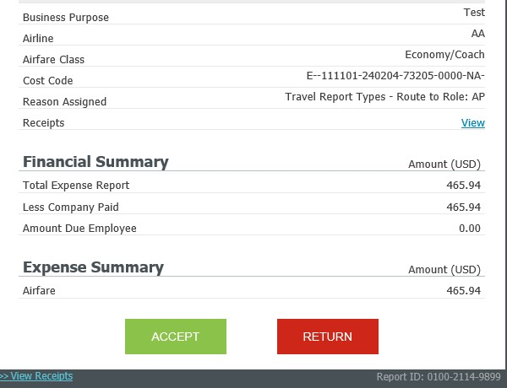
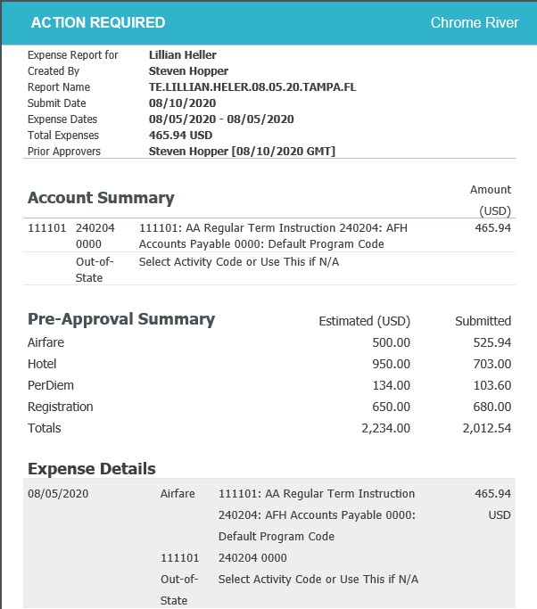

- Any compliance issues for line items will be noted with a Compliance Warning flag, as well as an explanation of the compliance issue and a response from the expense owner.

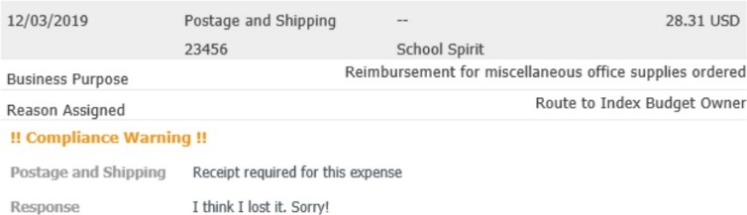
- After reviewing all items, if you would like to approve the report, press the green ACCEPT button at the bottom of the email.
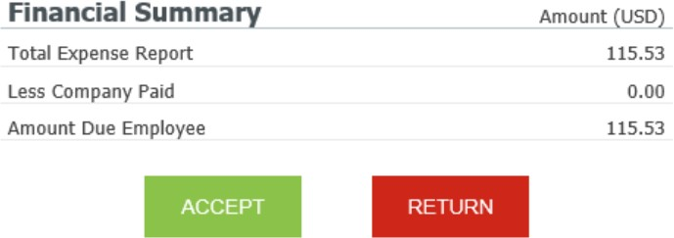

This will open a new email window, and you will need to click Send. After submitting this email, the report will move forward in the approval queue. You may enter additional comments as well.
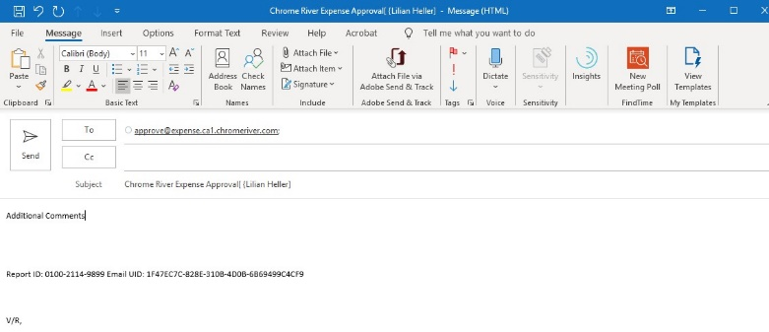

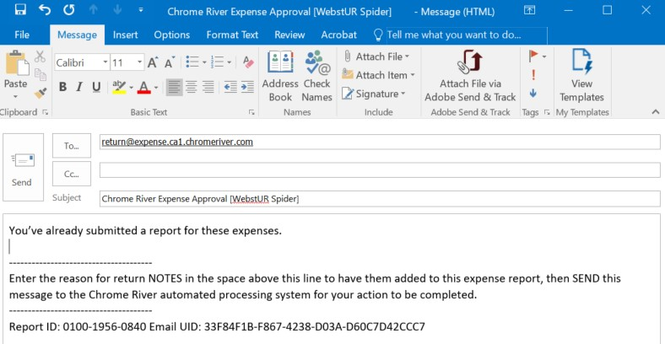
If you would like to return the report, press the red RETURN button at the bottom of the email. This will open a new email window where you should enter an explanation of why you are returning the report. Hit Send and the report will return to the submitter for corrections.

CHROME RIVER QUICK GUIDE – APPROVING REPORTS

Forwarding the Email

1, If the first option fails to default to your ECU outlook email, sending from a non ECU address will not work.
2. You can still use your email and simply forward the email that came to you from Chrome River after you review the information and if you are satisfied with the information forward that email to approve@expense.ca1.chromeriver.com That email address is located under the ACCEPT Button. 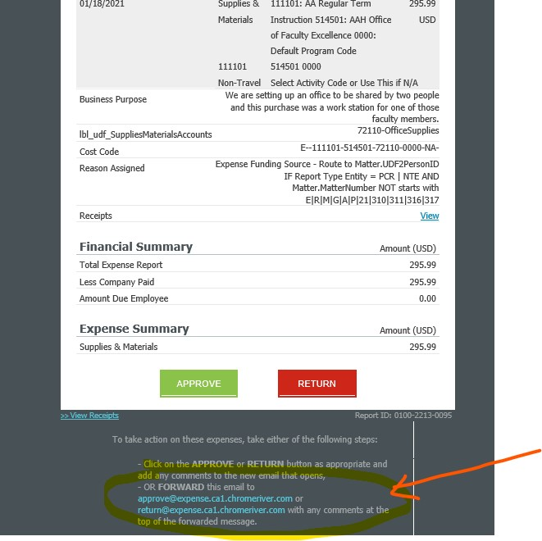
Likewise if you need to return it forward the email to return@expense.ca1.chromeriver.com

Approving in Chrome River Application
- Log in to Chrome River located on the PiratePort and sign in.
- Any reports awaiting approval will be noted in the Approvals box on your Dashboard. Click on Expense Reports or Pre-Approvals to access the list of reports awaiting approval.

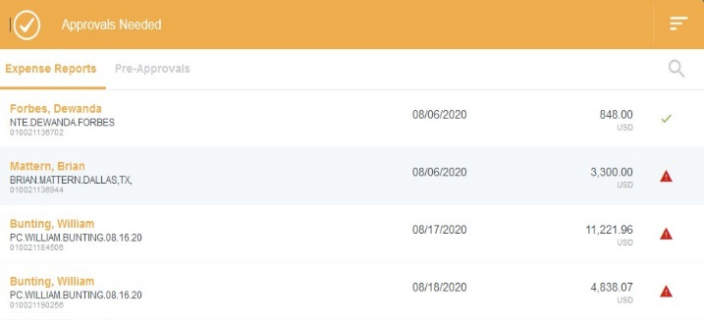
- From the Approval List, select the report to review. Note that any reports submitted with compliance warnings will be noted with a red triangle icon on the line of the report.

- Click on the report to review, and the report header will display in the window to the right, including a summary of expenses, funding sources, and all attached receipts.

From the report preview, you can perform the following functions via the buttons at the top of the preview:
  - Open – Opens the full report
  - PDF – Provides options for printing the report to PDF
  - Tracking – Provides summary of the tracking of the report items
  - Return – Returns the report to the submitter
  - Approve – Approves the full report
  - Reassign – Clicking on ••• will display option to reassign the report to another approver. Generally, this functionality should not be used. If you believe you received a report to approve in error, please contact Accounts Payable.
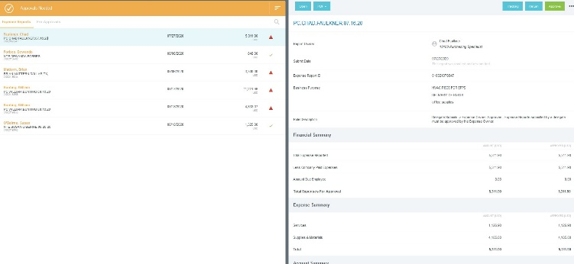
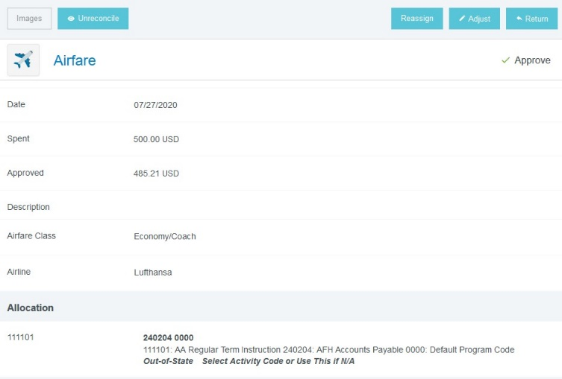
- We encourage approvers to Open the full report to review all individual expenses. To view details of an expense, click on the expense in the summary on the left and the details will display on the right, including any receipts.

Similar to reports, approvers can perform several functions on individual expenses via the buttons at the top of the expense:
  - Reassign – An approver can reassign an expense to another individual for possible policy exceptions or scrutiny. Simply type name of individual and send.
  - Adjust – Adjust the approved amount (approvers can only adjust this down), business
purpose, FOAP, or add a comment
  - Return – Return an expense to the submitter

Note: The functions above will not occur until the approver hits the Submit button on the report, as described below.

After you have reviewed the report, made any applicable adjustments, and are ready to move the report forward, click the Submit button at the bottom of the expense report summary

CHROME RIVER QUICK GUIDE – APPROVING REPORTS

The submit confirmation screen will now appear. Again, click Submit.

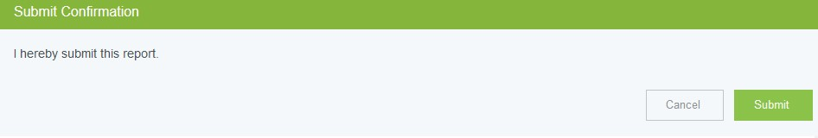

A submit confirmation will be displayed. All approved expenses will move forward in the approval queue. Any reassigned or returned expenses will route accordingly.

