CHROME RIVER QUICK GUIDE – REQUESTING & CLEARING A CASH ADVANCE
Requesting a Cash Advance

All requests for cash advances must be requested and approved through a pre-approval report in Chrome River. Note that travel advances are only allowed in limited circumstances, typically when a credit card cannot be used as an appropriate or effective means of payment.

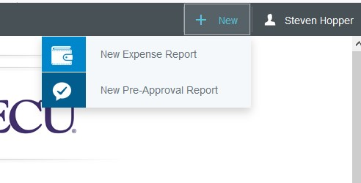
- To create a pre-approval report, click the + New button on the Navigation Bar and select New Pre- Approval report from the dropdown menu.

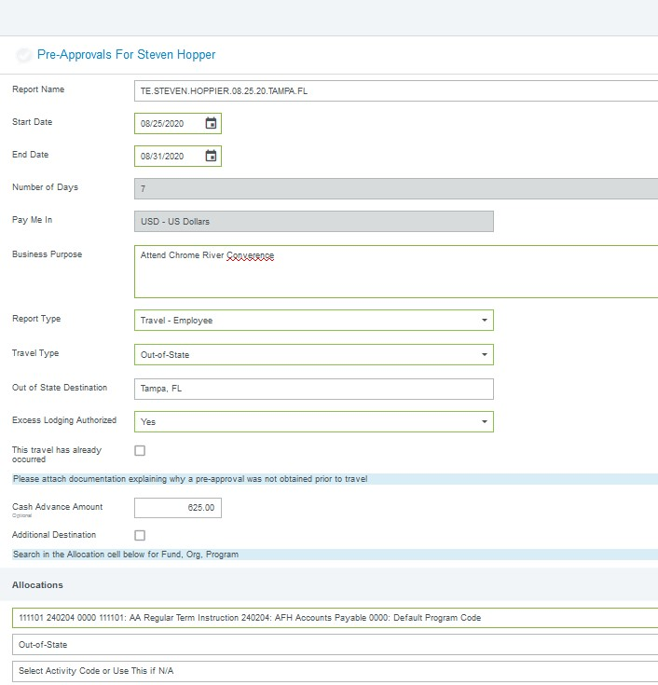
- Complete the pre-approval report header, select Cash Advance Requested under the Cash Advance field. Additionally, enter the advance amount requested under Cash Advance Amount.
Prepare the Pre-Approval and add the other estimated expenses and hit submit.
After the report header has been fully completed, click Save in the upper right corner of the header to continue. You will now be given the opportunity to add any applicable expenses to the report, submit it for approval as normal. (For a more detailed explanation of creating and completing a pre-approval header and report, see the Create Pre-Approval Report Quick Guide.)

If the cash advance request is approved, the advance will be paid 2 weeks prior to the departure date. Also, the advance must be cleared on an Expense Report within 30 days after completion of the trip or event and excess funds must be returned to the Cashier’s Office prior to clearing the advance, as described below.
Clearing a Cash Advance

After creating an expense report and adding all appropriate expenses to it, you will need to add the cash advance expense to account for the amount already received. (For a more detailed explanation of creating and completing an expense report, see the Create Expense Report Quick Guides.) Any previously approved cash advances will appear in your eWallet under Cash Advance. To add it to your expense report, select the checkbox on the cash advance line and click Add in the top right corner.

The Cash Advance Expense Form will now display. The Transaction Date and Spent amount will automatically populate with the values previously approved. Confirm that a Business Purpose has been entered, click Save in the top right corner.

The Cash Advance should be charged to the exact same FOAP as when it was issued.

The amount of Cash Advance will “reduce” the amount of reimbursement due.

In the event you did not spend the entirety of the advance, University policy requires that unused funds must be returned to Accounts Payable Office. Funds can be returned in the form of a personal check, money order, or credit card. If you want to pay via credit card, please send the Chrome River office an email (ECU_Chrome_River@ecu.edu) and we will forward you instructions and the link to make payment via credit card (this is using U-Store functionality).

The Accounts Payable office is located at 120 Reade St, Greenville, NC. The office phone # is 252-737-5700.

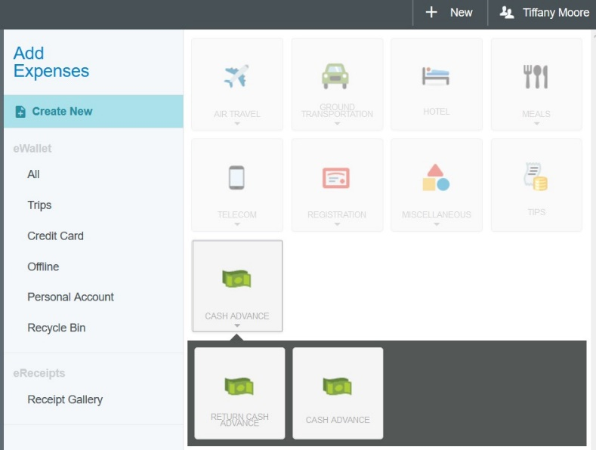
Additionally, you will need to add a Cash Advance Return expense to your report. Select Create New in the Add Expenses window to display the expense tile mosaic and select the Cash Advance Return tile.

Complete the Cash Advance Return Expense Form by entering the value of the cash advance that was returned in the Spent field and clicking the checkbox certifying that unused funds have been returned to the Accounts Payable Office. Attach a copy of check, money order or U-Store email string in the in the Attachments section at the bottom of this form. Click Save to add the Cash Advance Return to your report. The Total Pay Me Amount should now be $0, and the report can be submitted. Note: Expense Reports cannot be submitted for amounts <$0.00

