CHROME RIVER QUICK GUIDE – CREATING A PCARD REPORT

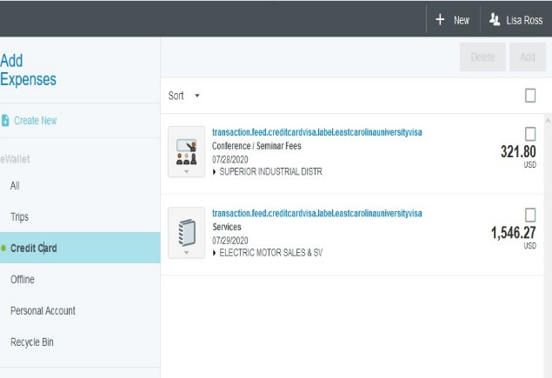
- Click the + New button on the Navigation Bar and select New Expense Report from the dropdown menu.
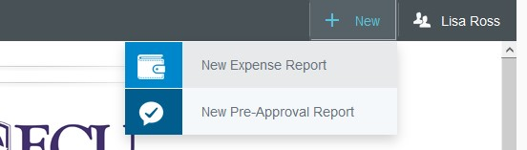

- Complete the expense report header with the following:
  - Report Name – Include the card name and an indication of the date range in your report name (e.g., PC.Lisa.Ross.11.13.20) *Note 11/13 was the date of her earliest transaction, file 25 days after 11/13 or Dec 7.*
  - Report Type –Select Pro Card Reconciliation

After the report header has been fully completed, click
Save in the upper right corner to continue.

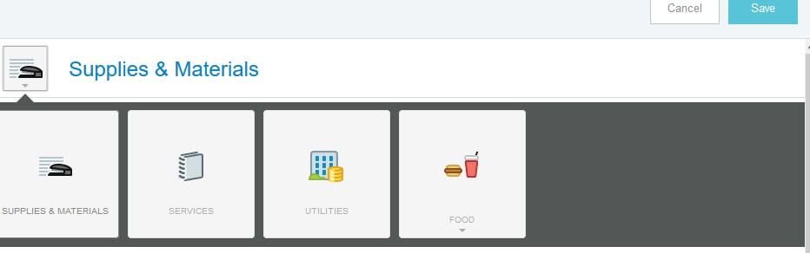
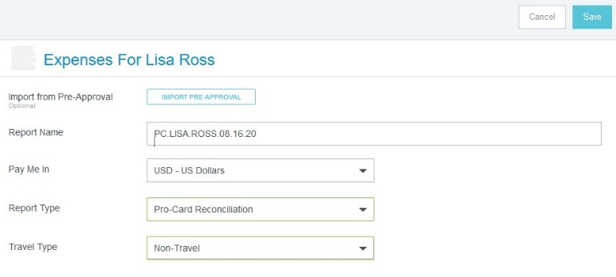

Add Expenses

- The Add Expenses window will now display on the right side of the screen. Click on the Pro Card line in your eWallet to view all of your unallocated Pro Card charges.

- Select the checkbox next to any transaction you would like to add to your report and click the Add button in the upper right corner.
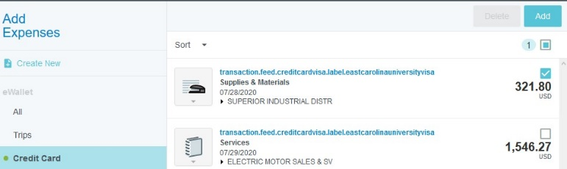

- You will now need to select the appropriate expense tile for this expense from the expense tile mosaic. Tiles with a downward facing arrow at the bottom are “parent” tiles that have additional expense tiles organized under them.

In some instances, Chrome River may use the MCC Code of the vendor to automatically populate the expense type. Please review any of these instances to confirm they are accurate. If they need to be changed, click the tile, and you will be allowed to select a different expense tile from the mosaic.

CHROME RIVER QUICK GUIDE – CREATING A PCARD REPORT

8. Continue adding expenses to your report by selecting transaction and corresponding expense type, completing the expense tile form, and saving.
Submit
- Complete the expense tile form, including adding a receipt and selecting the FOAP where the expense should be charged. Click Save in the upper right corner to continue.

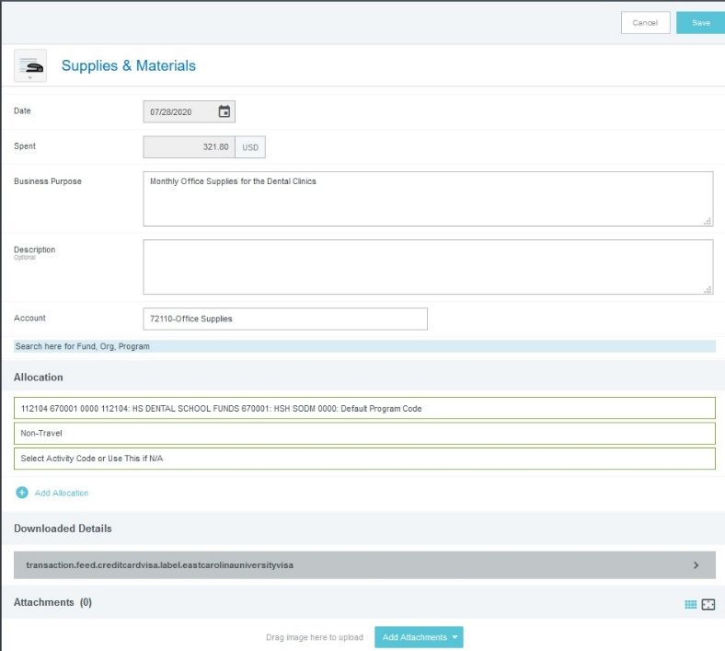

- The expense will be added to your Pro Card report and will be visible on the report summary to the left. The Add Expense window will appear again on the right side of the screen.
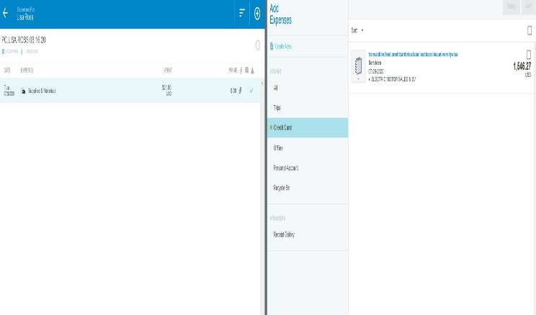
- Once you have finished adding all Pro Card expenses to your report, click the green Submit button at the bottom of the report summary.
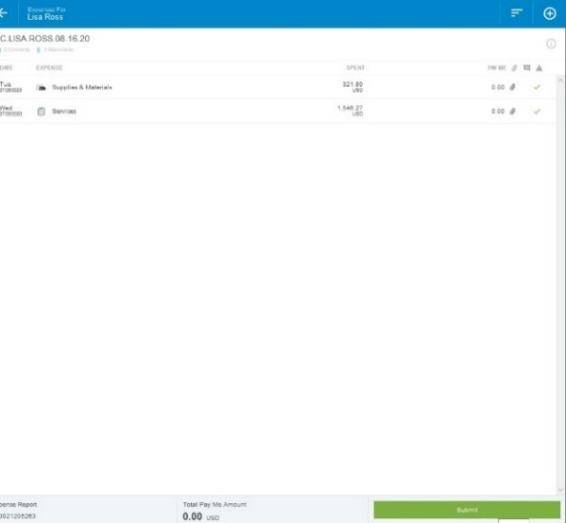

- A submit confirmation will appear at the top right of the screen. Click Cancel to return to the report and make any changes. Click Pre-Approval to attach a previously submitted pre-approval report to your Pro Card report for informational purposes. Click Submit to submit the Pro Card report to the approval workflow. (Note: Pro Card reports should only be submitted when you have 25 items or every 25 days. Reports must be submitted and fully approved by 30 days)

