CHROME RIVER QUICK GUIDE – CREATING A HOTEL EXPENSE

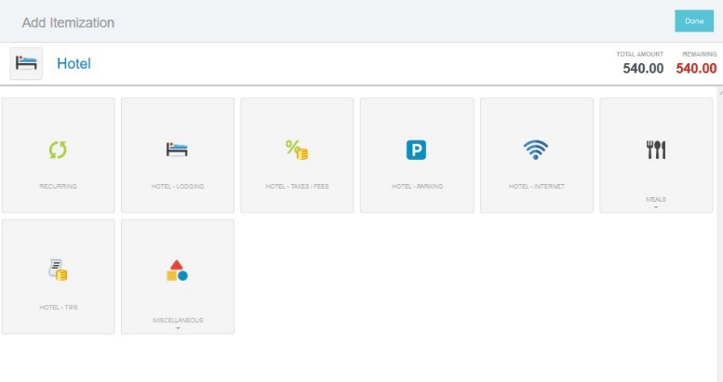
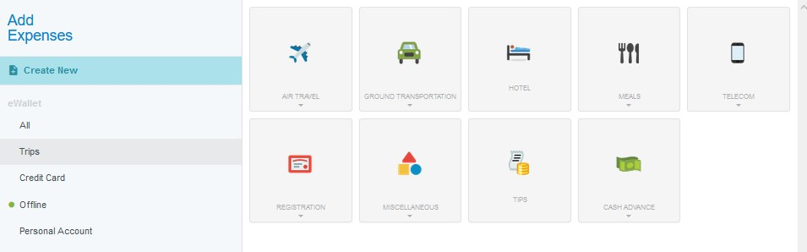
- From the Add Expenses window in the applicable expense report, select Create New to access the expense tile mosaic.

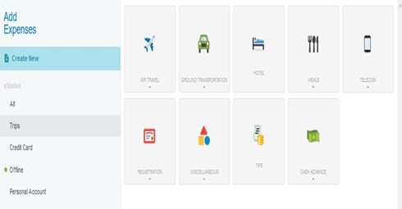
- In the mosaic, select Hotel.

- Complete the expense tile form, including uploading your hotel receipt/folio and selecting the appropriate FOAP. Once completed, click Itemize in the top right corner. (Note: Any personal expenses on the hotel folio should be excluded from the Spent amount, Show the math on the receipt)
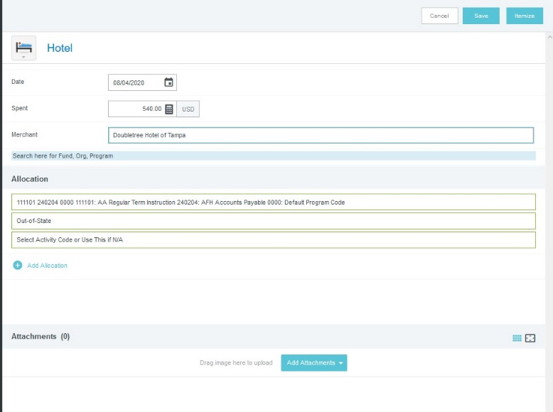
- This will open the Add Itemization window. If your stay included expenses that were the same amount across multiple days, you may use the Recurring tile to enter those expenses.

- On the Recurring tile, enter the Check-In and Check- Out Dates and the daily amounts for Lodging & Taxes, Parking, and/or Internet. Click Save, and the expenses will be added to your report for each day of your stay. (Only helpful if all days are same price.)
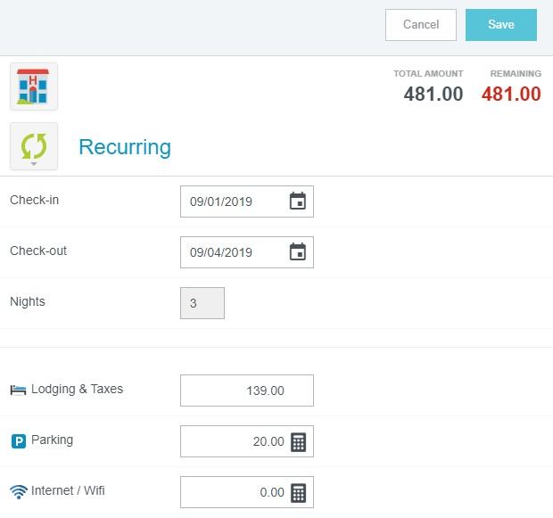

- If your hotel expenses did not stay the same or you would like to add items individually, do so by clicking on the appropriate expense tile. For example, to add the cost of lodging (including taxes and fees such as resort fees), click the Hotel – Lodging tile.

CHROME RIVER QUICK GUIDE – CREATING A HOTEL EXPENSE
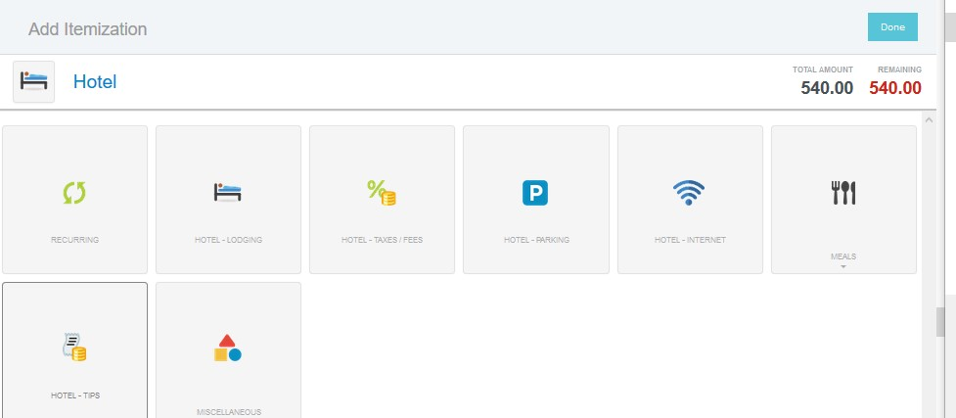

- Complete the expense form and click Save, and the expense will be added to your report. (Note: You do not need to create an individual expense for each night (i.e., you can create one Hotel – Lodging expense record that reflects the total cost of lodging. One for Total Cost of Taxes, etc.

- The expense will be added to the report summary on the left side of the screen and the Add Itemization page will again display on the right. The remaining amount to be itemized will be displayed in the upper right corner. Continue adding any additional itemized expenses (such as internet, parking, etc.) until the bill has been fully itemized and the Remaining amount equals zero.

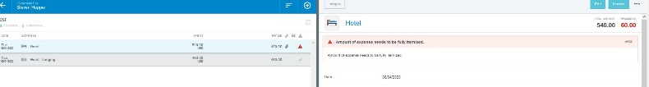
- Once all expenses have been itemized, the Add Itemization window will disappear and all the itemized expenses will now appear on your report. (Breaking out the taxes is OPTIONAL)
