CHROME RIVER QUICK GUIDE – USING THE ITEMIZATION TILE

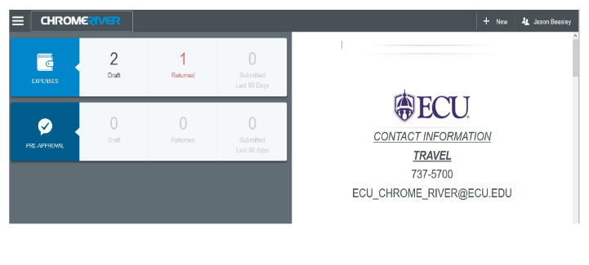
- Click the + New button on the Navigation Bar and select New Expense Report from the dropdown menu.

- Complete the expense report header with the following for the Itemizations.
  - Report Name – Include the card name and an indication of the date range in your report name (e.g., PC, Jason Beasley– 10-12, 2020)
  - Report Type –Select Pro Card Reconciliation

After the report header has been fully completed, click
Save in the upper right corner to continue.

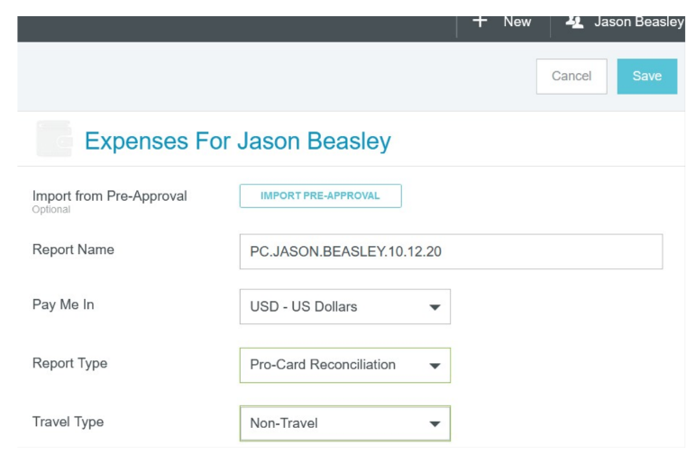

Add Expenses

- The Add Expenses window will now display on
the right side of the screen. Click on the Pro Card line in your e-Wallet to view each of your unallocated Pro card.
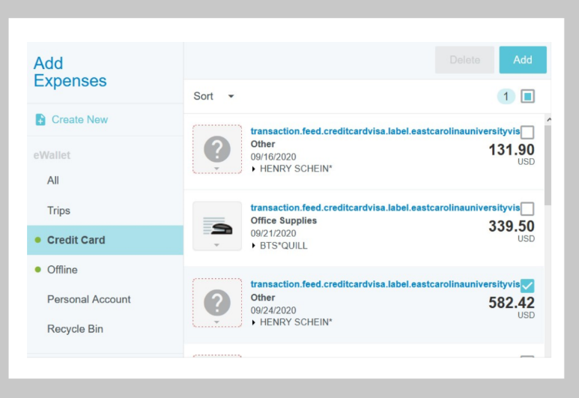
4. Select the checkbox next to any transaction you
would like to add to your report and click the
Add button in the upper right corner.

- You will now need to select the appropriate expense tile for this expense from the expense tile mosaic. Tiles with a downward facing arrow at the bottom are “parent” tiles that have additional expense tiles. Select the Itemization tile.

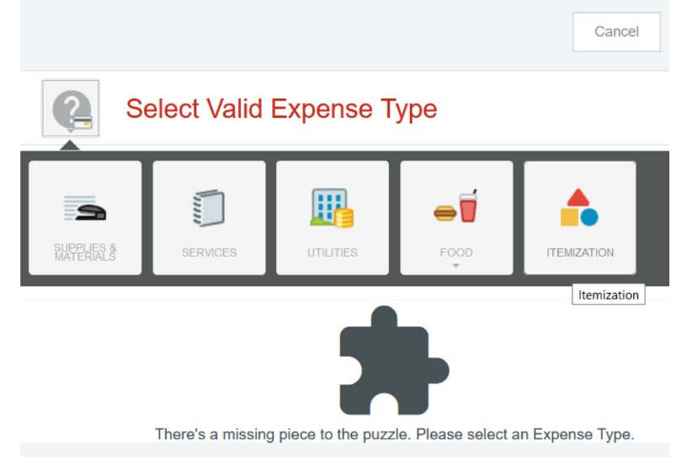

CHROME RIVER QUICK GUIDE – CREATING AN ITEMIZATION

7. Continue itemizing the expense to your report by selecting transaction and corresponding expense type, completing the expense tile form, and saving.
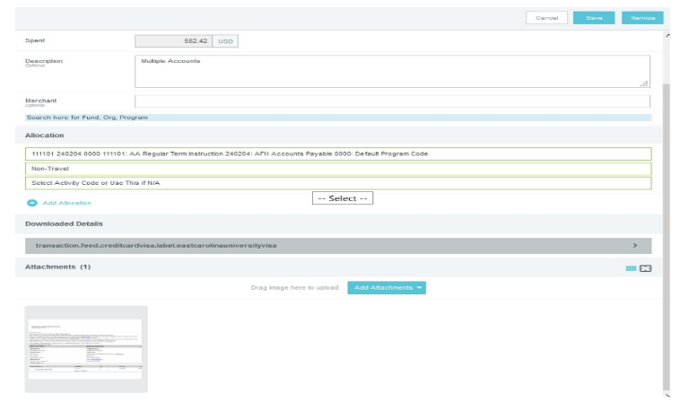
- Complete the expense tile form, including adding a receipt and selecting the FOAP where the expense should be charged. Click Save in the upper right corner to continue.

- The expense will be added to your Pro Card report and will be visible on the report summary to the left. Now you must ITEMIZE the expense and account for the entire amount. Different Account Codes, and FOAPs may be selected.
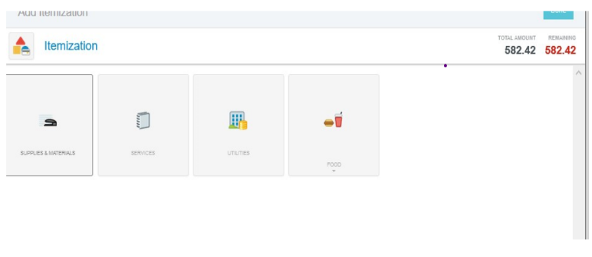
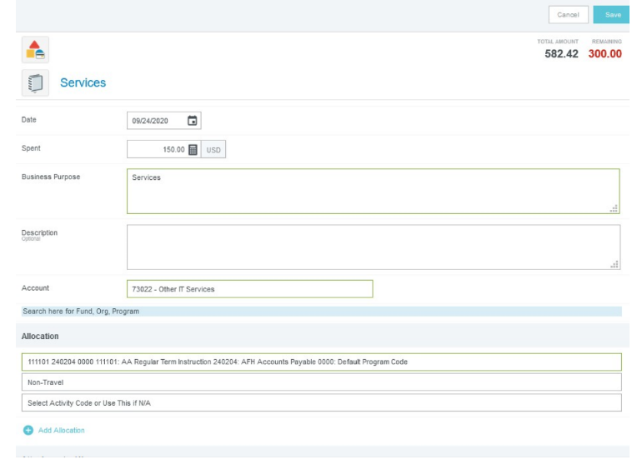
8. Once each entry equals the beginning amount for each amount chosen for the purpose of itemization there will be green check marks to the far right of the lines chosen; ex. Supplies & materials, Services, Food Products.

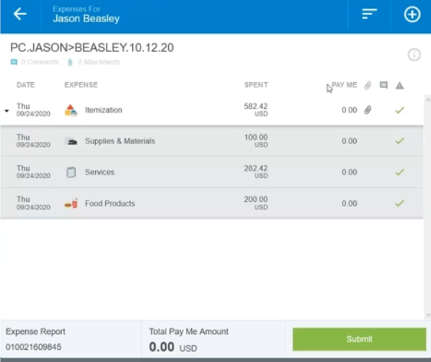

Submit

