CHROME RIVER QUICK GUIDE – CREATING A MILEAGE EXPENSE

- From the Add Expenses window in the applicable expense report, select Create New to access the expense tile mosaic.
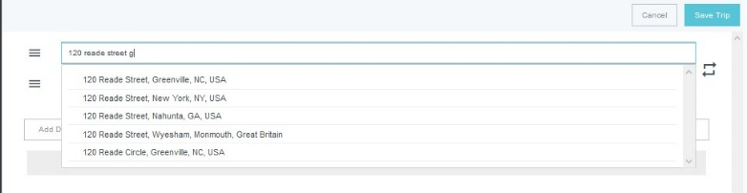
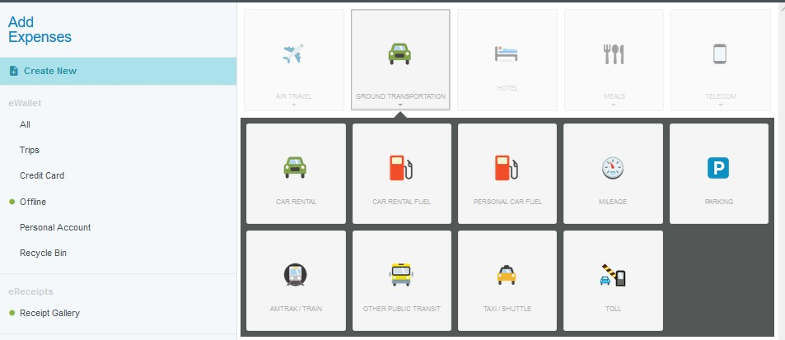

- In the tile mosaic, select Ground Transportation
followed by Mileage.

- Complete the expense tile form with the following information:
  - Transaction Date – Record the date of travel. For multiday trips, you do not need to create separate entries. Just enter the first day of travel
  - Description – Leave this field blank. It will
  - populate with the actual route information
  - entered on the Calculate Mileage page
  - Miles – This field will populate based on the information entered on the Calculate Mileage page
  - FOAP – Enter the FOAP to which this expense will be charged

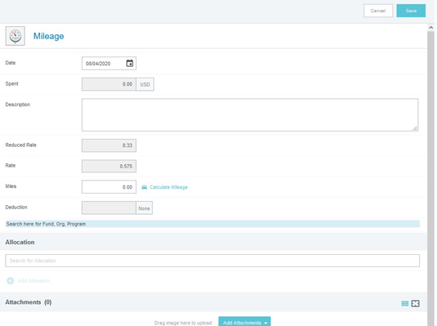
Click on the Calculate Mileage link next to the Miles. field to enter your route

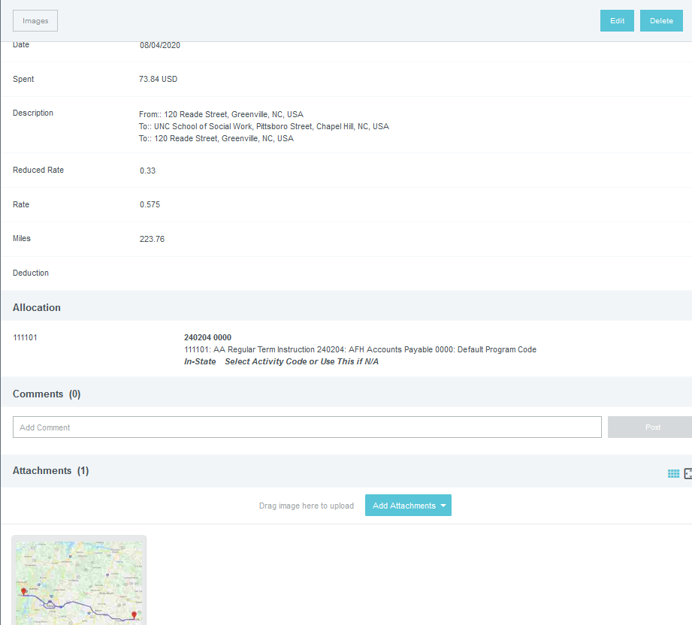
- Enter the address of your start and end location. As you begin typing, the system will provide suggestions.

- If you stopped at multiple destinations, you can click
Add Destination.
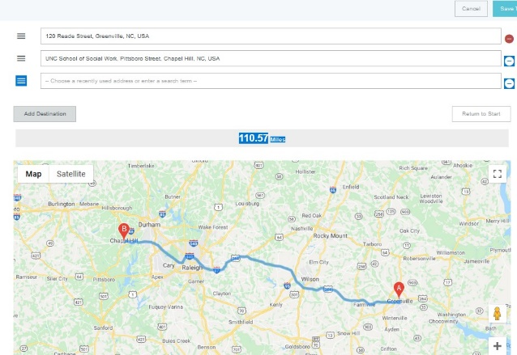

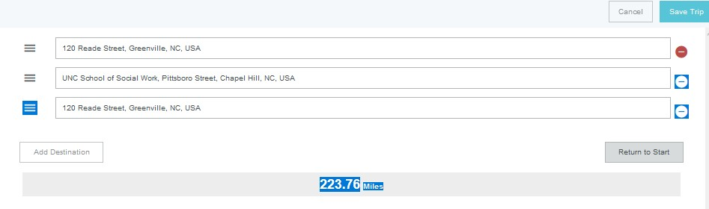
- If this is roundtrip, you can click Return to Start to add an entry returning to the original location.

- Your trip will be reflected on the map displayed below. This feature uses Google Maps and has similar functionality, allowing you to drag and drop the path to adjust for alternate routes.

- Once complete, click the SAVE TRIP in the upper right-hand corner.

