CHROME RIVER QUICK GUIDE – CREATING A PER DIEM EXPENSE

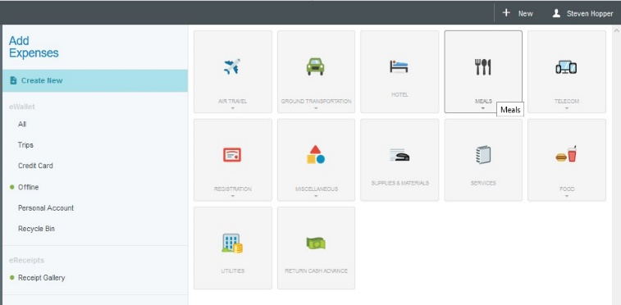
- From the Add Expenses window in the applicable expense report, select Create New to access the expense tile mosaic.

- In the tile mosaic, select Meals
followed by Meals – Per Diem Wizard.

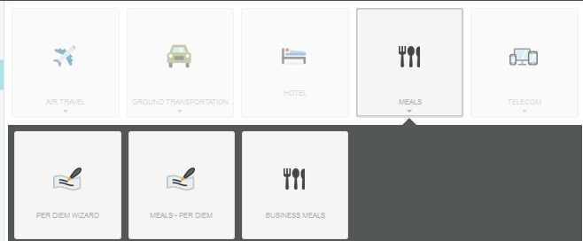

- Complete the per diem wizard form on the left with the following information:
  - Start Date – Enter the first date you are claiming per diem and the time leaving home
  - End Date – Enter the last date you are claiming per diem and time you plan on arriving home.
  - Days – This will calculate automatically based on the dates entered above
  - Location – In-State; Out-of-State; International
  - Description – This is optional
  - Location – Enter the location in which you will be claiming per diem
  - Allocation – Enter the FOAP to which this expense will be charged

Then Add Entries

Once complete, click Add Entries at the bottom.
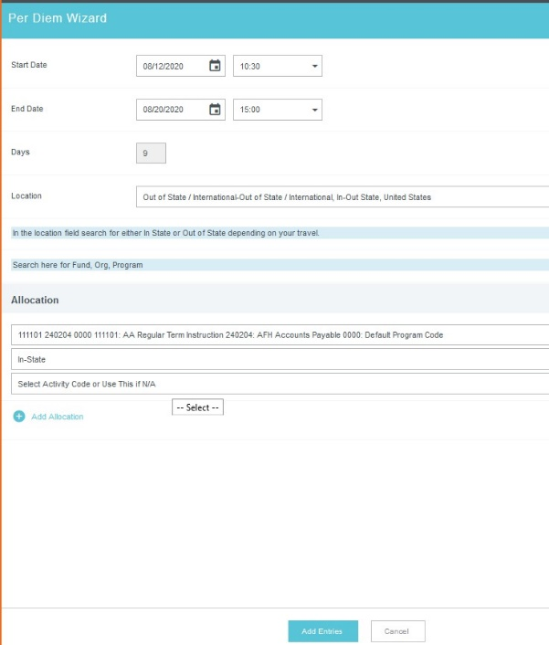
- The system will create an entry for each day, displayed on the right side of the screen.
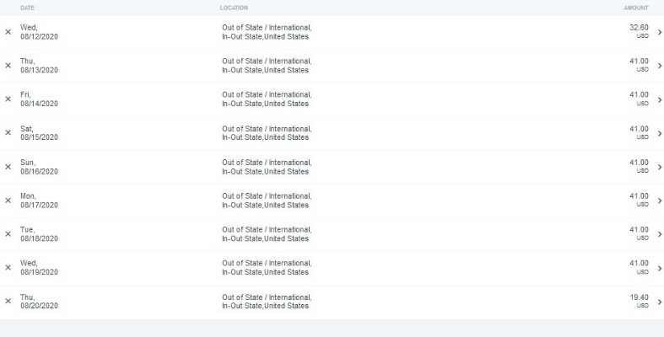

- Clicking the arrow next to each entry will open the Deductibles section. Per the University’s travel policy, travelers may claim meal per diem only for meals that were not otherwise provided during travel. If a meal is included in a conference, paid for by another colleague, vendor or other third party, or when traveling a partial day, the full per diem amount should not be claimed. To reduce a daily per diem, select the appropriate date and click the checkbox to indicate any meals that should not be reimbursed. When meals are marked in the Deductibles section, the system will automatically reduce the daily per diem to the appropriate amount
per the University’s Travel Policy.

CHROME RIVER QUICK GUIDE – CREATING A PER DIEM EXPENSE

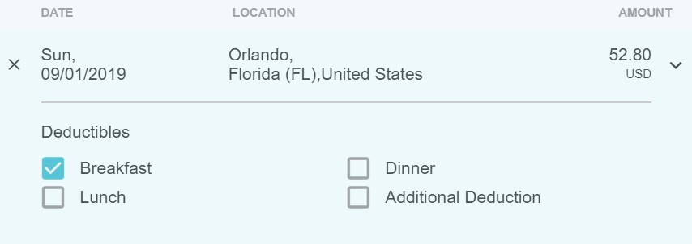

- After making any appropriate deductions, click Add to Report in the bottom right corner.
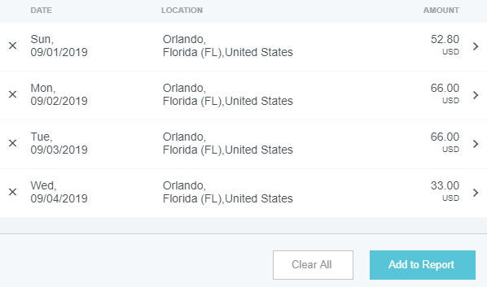

- Your report will now have a line item for each day of per diem reimbursement listed on the report summary.
