CHROME RIVER QUICK GUIDE – TRAVEL EXPENSE REPORT WHEN PROCARD MADE BY OTHER USER

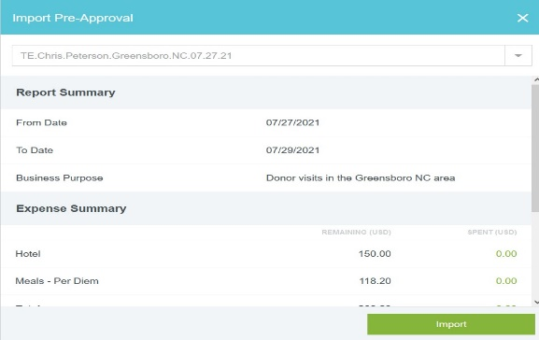
- Once the ProCard Transaction appears in the ProCard Holder’s eWallet and that transaction supports another ECU Employee/Student/Resident traveling, the transactions(s) MUST BE MOVED to the traveler’s eWallet.
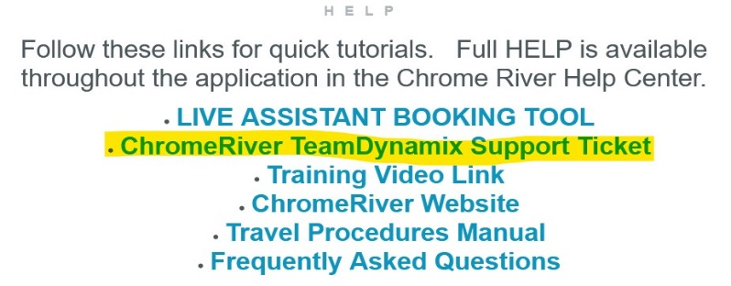
- Go to the Team Dynamics Link located at the bottom of the Chrome River Home Page on right side.
- Select Chrome River Service Request and Request Service and sign in.

- Service Request Type – Select “Assign ProCard Charge to others” and complete the required information “description of Problem, ProCard Holder Name, Procard Holder Banner ID, Transaction Date, Transaction Amount,
- Traveler Name, Traveler Banner ID, etc. if you have have more than one transaction answer YES to the “Add another transaction?”

- Submit your ticket. It normally is completed within 5 minutes of you submitting your ticket.

- Once confirmed the transaction is moved to the Traveler’s eWallet it is ready to be added to a report.

- ProCard transactions must be processed within 25 days of receiving them in the eWallet; therefore many times, a Travel Expense Report must be completed PRIOR TO THE TRAVEL simply to expense the ProCard transaction(s), i.e. Airfare, Registration fees, etc

- Completing a PREMATURE Travel Expense Report to expense the ProCard Transactions.

Go to Traveler’s account and + Create New Expense Report.
- IMPORT THE PREAPPROVAL

- This will populate some of the fields on the Header Sheet; however others still must be completed.

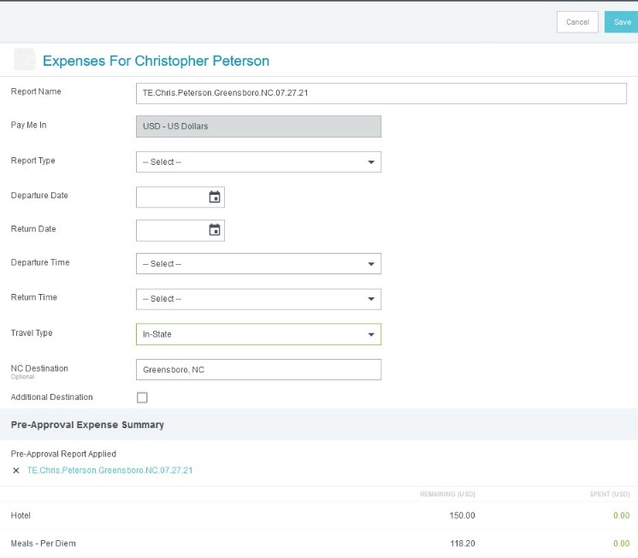

- Report Type, needs to be completed, whether it is Travel-Employee; Travel-Student, etc DO NOT USE PROCARD TRAVEL RECONCILIATION for this report type. It is used for other reasons.
- Depart Date, Return Date, Times of departure and times of return.

- Then you will notice in the Pre-Approval Expense Summary the attached Pre-Approval. Next to the name, hit the “X” button, this will then unattach “temporarily” the proper Pre-Approval. NOTE We will reattach at our last step, but this will avoid you having to delete all lines on the PreApproval, when only expensing the ProCard Transaction early.

- Then in the upper Right Corner, click SAVE.

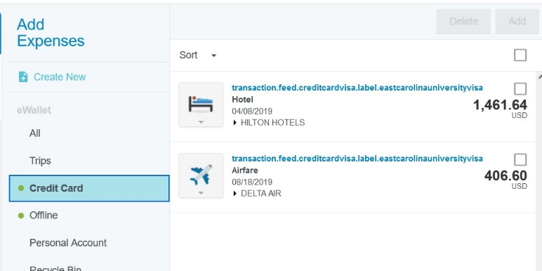
- Go to the Credit Card Area and you will see the transactions that were recently moved. i.e. Hotel, Airfare, etc

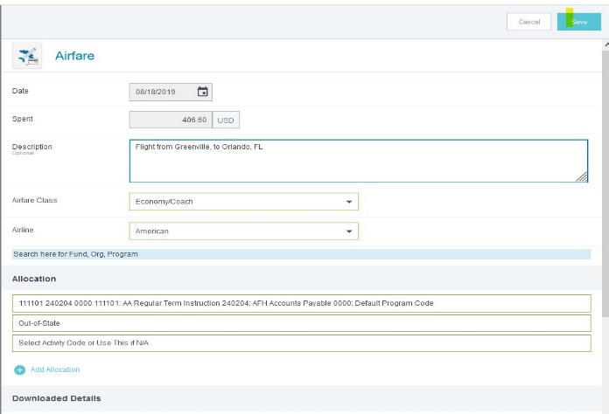
- Click on Airline First and select Add. Then complete the required information Description, Airfare Class, Airline, add the proper FOAP, and a receipt

- Repeat process to add any additional ProCard Transactions. Note that only ProCard charges will generate a “Premature” travel expense report. If a traveler personally paid early for a trip, they will not be reimbursed until after the trip concludes.

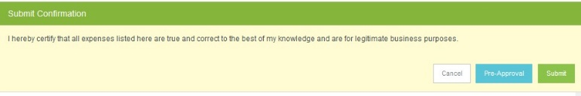
- Once you click submit on left side, you will see a Pre-Approval button on top right side.

- Click the Pre-Approval and REATTACH the Pre-Approval that you originally selected in Step 11. This will then bring back at reattach that Pre-Approval.

- Then Submit. Note you will get a warning stating “Expense Report Create Date is before the Start date” This is to be expected and simply put “ProCard Transaction” and post.

- It is imperative that the PreApproval is attached, to ensure the Encumbrance that the Pre-Approval established against your budget lines is reduced by the amount of the ProCard Transaction.

- When traveler returns from the trip, you will complete another Travel Expense Report for all reimbursable items, less the ones you expensed early, i.e. airfare, registration, etc

- NOTE: It is possible to have 2 – 4 Expense reports for a Pre-Approval depending on the timing of the ProCard purchases, ie. Registration purchased 6 months early, Airline 3 months early, Hotel 2 months early and then after return.

8

