CHROME RIVER QUICK GUIDE – REPORT TRACKING

Users can track the current status of any previously submitted pre-approval or expense reports at any time.

- From the Dashboard, select the Submitted report link.
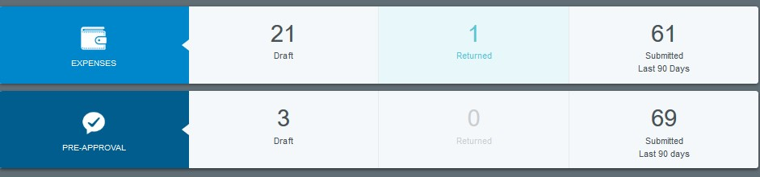
- From the list of submitted reports, click on the desired expense report to preview it. Then tap Tracking in the preview. (On mobile, tap the expense report to open the preview and then tap the ••• button and click Tracking from the drop- down list.)

- You will now see a list of every item on the report along with its status. (For Hotel or Itemized expenses, tap the arrow on the left to view the status of each itemized item.) The following are the possible statuses:
  - Pending: Expense has been submitted and is awaiting approval
  - Returned: Approver has sent the expense back to the expense owner for adjustment
  - Approved: Expense has been approved but has not yet been exported
  - Exported: Approved expense report has been exported to Banner and OnBase
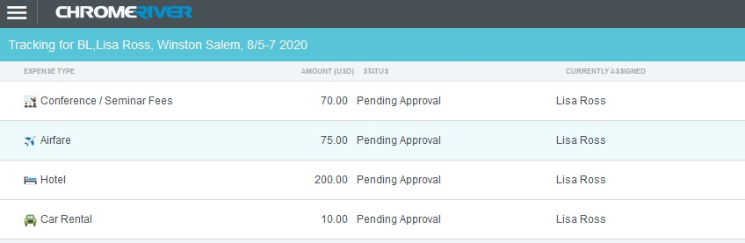
Tap an expense item to see where it is in the approval process, including the approver to whom it is currently assigned, the date it was assigned, and the system rule that triggered the assignment. Tapping each circle under Routing Steps will show you complete details for that step.

Each Night Chrome River System will send reminder emails to the approvers that they have an action(s) pending their review. This will help ensure the reports are processed in a timely manner.

Note: You may find that the routing steps include GateKeeper or Auto Approve. GateKeeper is a holding step that ensures all expense lines on the report are approved before moving forward to the next approval step. Auto Approve will show for any future GateKeeper steps. These steps automatically complete as soon as all expense lines have completed the prior approval step.
Revised 10 25 2022 Page 1

