CHROME RIVER QUICK GUIDE – CREATING A NON TRAVEL EXPENSE REPORT (DIRECT PAY)

- Click “Create New”
New Expense Report
Enter Report Name
(NT prefix to identify
Expense Report type,
cardholder last name, first name, receipt date)
example NTE.Steve Hopper.02/02/2021
Select “Non-Travel - Employee Only”
from the Report Type dropdown
Select “Non-Travel” from the Travel Type dropdown
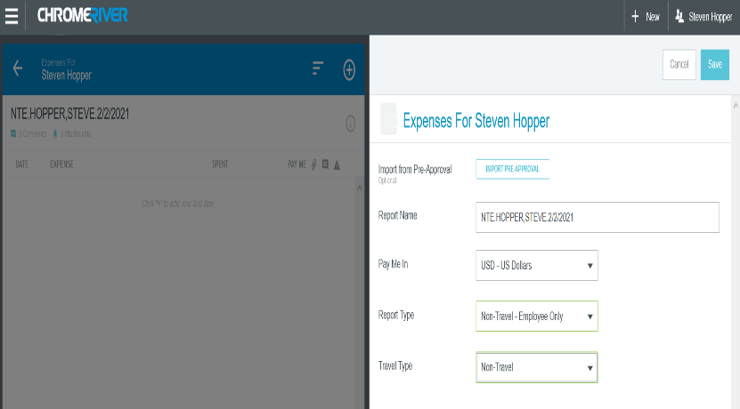
Click “Save”

- Select Valid Expense type
Enter the Transaction Date
Enter the Transaction Amount
Enter a detailed Business Purpose
If needed, enter Description
Select Account from the dropdown list
Allocation Section
Select FUND and ORGN from the dropdown list
Select Non-Travel from the Expense Type dropdown list
Select Activity code if applicable. Select “Select Activity
Code or Use This if N/A” for 0000
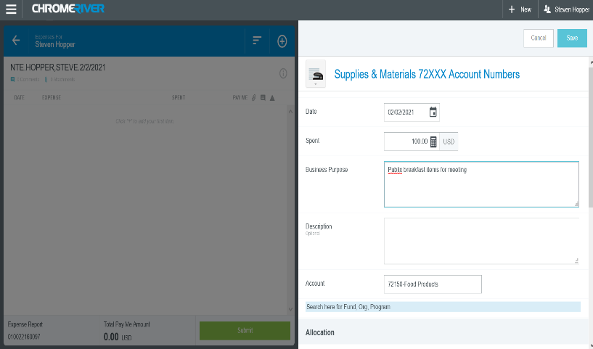

3. Methods: Receipt Gallery, Upload from PC
Receipt Gallery stores the attachments (receipts and
backup documentation) that are submitted electronically (emailed or CR SNAP) Upload scanned receipts and backup documents from PC
Use caution when scanning documents to ensure that no confidential information is scanned. Redact credit card info, research participant names, etc.
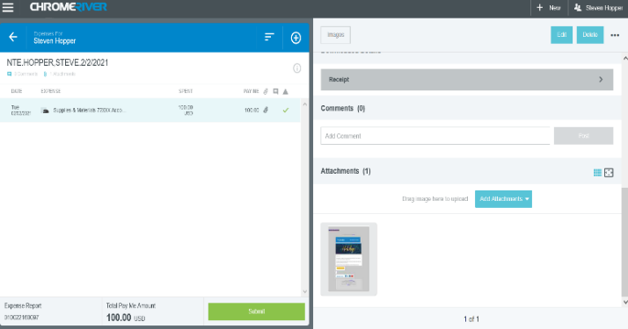
NOTE: Attachments must be formatted as PDF, JPEG, PNG, or TIF

- After all transactions are added to the Expense Report,
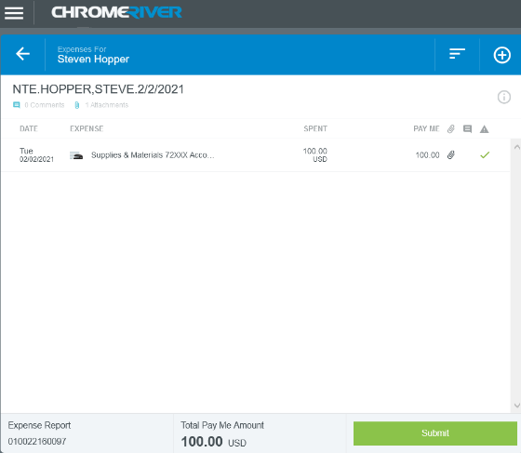
Click Submit for Confirmation.

The Expense Report will be listed on the Chrome River Dashboard in the Submitted Section
After the Expense Report is Submitted, the automated approval routing process begins as follows:
Expense Owner Approval
HR Supervisor Approval
Approval routing based on the business rules built into Chrome River
Approval by the Chrome River Office Staff
Transaction feeds to Banner nightly
Automated emails will be sent after each level of approval. Within the email will be a link for the approver to open and view the Pre-Approval Report or Expense Report. The approver can approve the Chrome River request within the email.

