Chrome River
Emburse Analytics
Detailed Departmental Dashboard
Dashboard Tips and Report Definitions

Dashboard Tips
The below report definitions are also listed on each report. Hoover over the “I” icon beside name of report.
Some reports can also be downloaded into Excel – click on the 3 vertical dots icon in upper right-hand corner of report.
Some reports will let you “drill down” to see more details. To do this, click on the field that you would like to explore more and the below box, or a version of this box, will appear. Click on Show All.
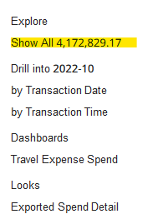
The Dashboard has two sections: (1) Historical Information and (2) Current Non-Exported Spend. There are also some additional reports toward the end of this dashboard (Accrual Entry, PreApprovals for Trips that have ended, Detail Analysis and Where’s My Report)

If you need any assistance with understanding/reviewing these reports or would like to change the output of your department dashboard, please email ECU_ChromeRiver@ecu.edu or call us at (252) 737-5700.

Historical Information Section

- Transactional Information Fiscal Year: This chart shows your Fiscal Year to Date between this year and last fiscal year. This represents ALL OF THE SPEND that has happened by month (cumulative) regardless of if it has exported (into Banner) or not.
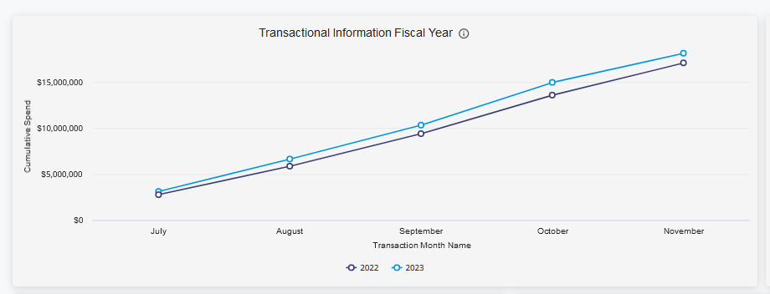
- Exported Information from the Past 2 Years (Fiscal Date Based): This Chart very similar to the first; however, this shows the Exported amounts per month, Fiscal Year to date (cumulative). This compares this year’s export to prior year export. This is what has come into Banner each month. (Keep in mind, it does not mean that the transaction took place that month, just when it was approved and exported).
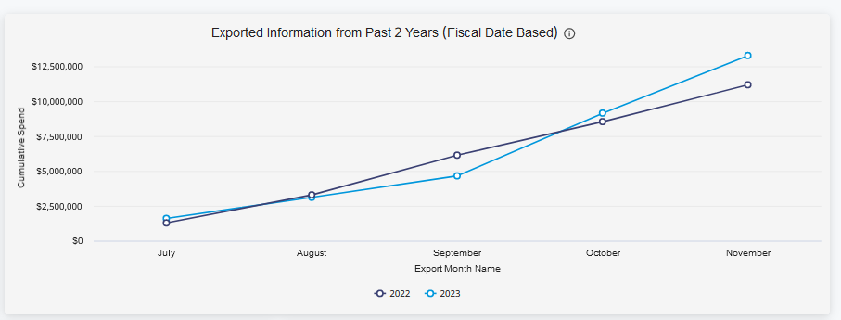
- Past 24 months of Spend: This is simply a “Rolling 24” of the monthly spend (All Categories of Spend). Great to find your “spikes” and “valleys” and traditional buying cycles for budgeting purposes.
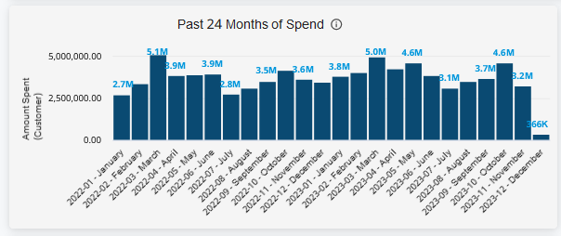
- Transaction Owner by Expense Type: This Pie Chart is showing the Expense types that are the “cost drivers” and the % of all the spend. This is using the same time period as in the above 3 reports.
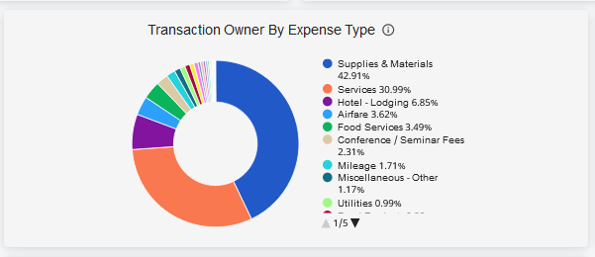
- Cost Category Change over past 12 CM to Prior: This is a table showing the Expense Types over the past 24 months. The middle column shows the total over the past 12 months, and then the 3rd column reflects the % change from the “prior” 12 months. This shows which costs are going up or down, etc. great for budgeting purposes.
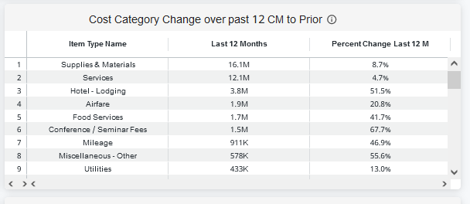
- Past 5 Years Transactional (Export vs Non Export): This chart shows you a rolling 5 year Spend. Shows the “Spikes” and “Valleys” of buying cycles. The dark blue is in Banner, while the “light blue” is not EXPORTED and still in Chrome River.
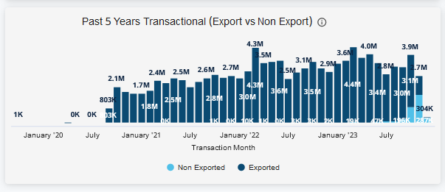
- Transaction Owner Allocation Usage: This shows you all the FOAPS that have been used in the spend captured. Helps shows you the FOAPS that are most popular. Great tool for budgeting and forecasting.
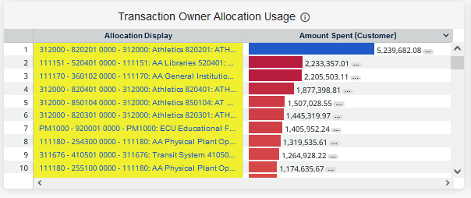
- Expense Owner Usage: Shows you the Expense Owner responsible for the amounts and how many “reports” created during the period. Good for evaluations, monitoring, etc.…
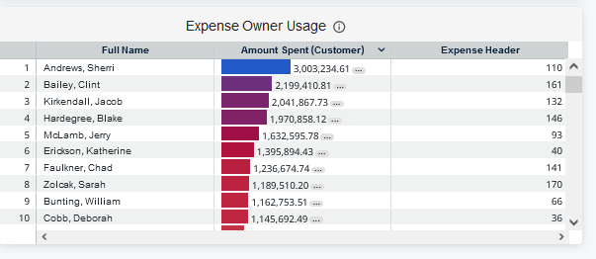

Current NON-EXPORTED SPEND (This is the area that represents expenses in Chrome River that have yet to be exported into Banner)

- Amount in Draft: Reflects those reports in an Expense Owners Draft pile, still building report, or has built and forgot to submit.
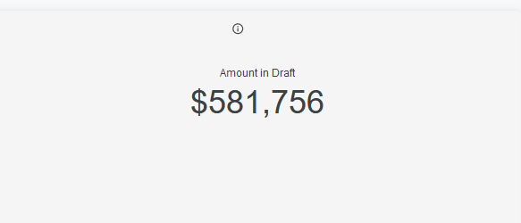
- Amount in Pending: This represents the total amount that is on a report that is working thru the approval process. The report is submitted but is not fully approved nor exported.
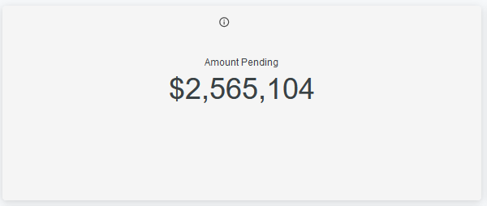
- Amount in Return: This reflects the total amount of reports that the current status of the report is “returned”. It was submitted, however an approver returned with comments for the expense owner to adjust and correct something.
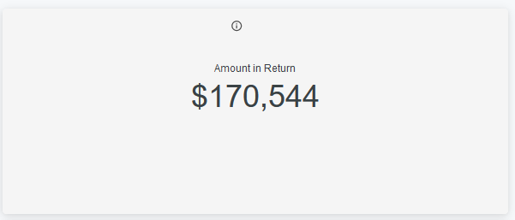
- Draft Report Detail: This report shows the “details” and can be downloaded to pull and track all reports in a draft status.
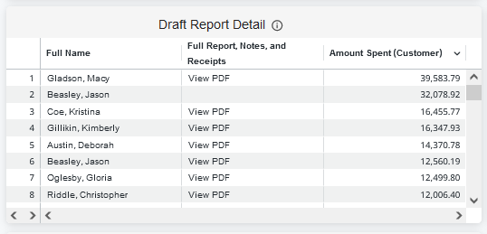
- Pending Details: This report shows the expense owner, as well as report name, the approver and number of days they have had the report. Great report to help find “bottlenecks” and keep reports moving thru the system.
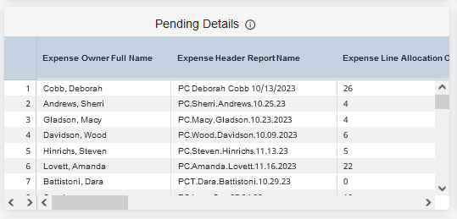
- Returned Details: Report shows the reports that are in a returned status. This should be monitored timely to keep reports from becoming stagnant or causing bottlenecks.
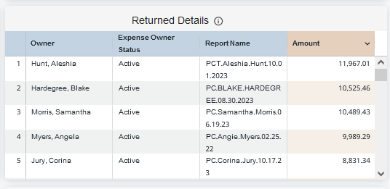
- ProCard Transactions in eWallets: Table shows the # of Transactions # of Card Holders and amount in respective “Aging Buckets” 0-15 days; 16-30; 31-60 and 61 and above. These transactions should be reviewed often, and reminders sent to reconcile in a timely manner.
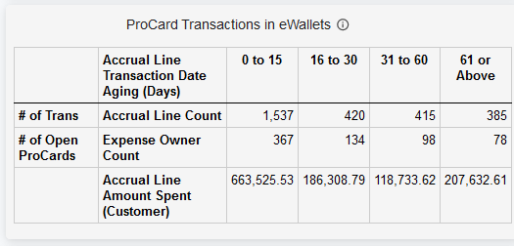
- Exported/NonExported by Calendar Year of Transaction: Report shows the transaction total of reports and what year the transactions falls in and whether or not it is exported or not.
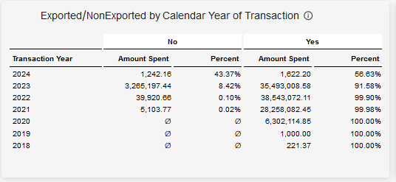
- AVG Submit Time by Report Type: Not Actionable, but shows the average submit times based on the report type. This report can be used for future training or targeting users to help them continue to submit timely.
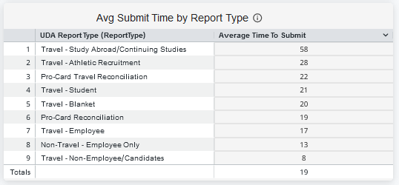
- Open ProCards: Detail of all cardholders and their ProCard transactions that have yet to be put on an expense report. Report is in transactional date order (oldest to newest). Report includes cardholder email, as well as cardholder supervisor email, so these individuals can be emailed to help get the transactions reconciled within 30 days in accordance with ProCard policy.
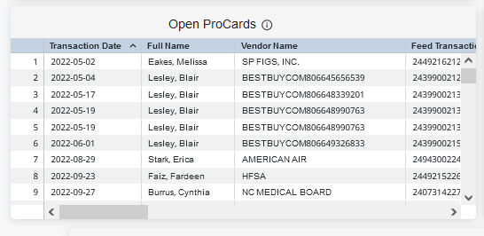
- Amount of Inactive Employees: This report reflects the total amount that is associated with employees who are in a “deleted” status that still have something that is in their profile that has not yet exported. NOTE: some of this may not be “valid” expenses; however, should be reviewed and deleted if applicable or moved to an active employee to submit on their behalf. The goal would be for this report to be $0.
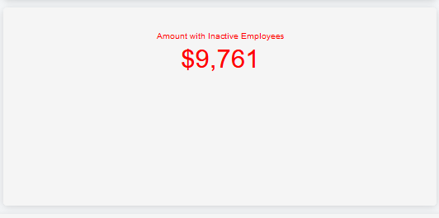
- The Detail Amount with Inactive Employees: This report identifies those reports still in Chrome River that are for inactive employees. The goal would be for this report to be $0.
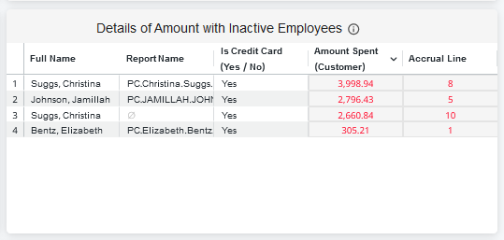
- Accrual Entry: This report reflects all the items that are in Chrome River, not Exported, and on reports (DOES NOT REFLECT EWALLET TRANSACTIONS). Here you can see the FOAPS and the total amount, so can be used to review balance in Banner and then see what is headed to that FOAP to make proper business decisions. Great for year-end use in creating accrual entries.
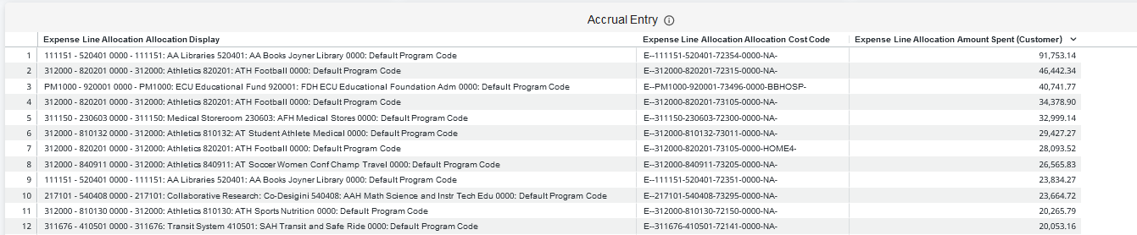
- PreApprovals for Trips that have ended: This report shows PreApprovals with a trip end date in the past. A PreApproval with a status of Approved indicates an expense report(s) has not been filed yet. A PreApproval with a status of Partially Applied means some, or all, expense reports have been submitted. This requires additional research to ensure ALL expense reports have been submitted.
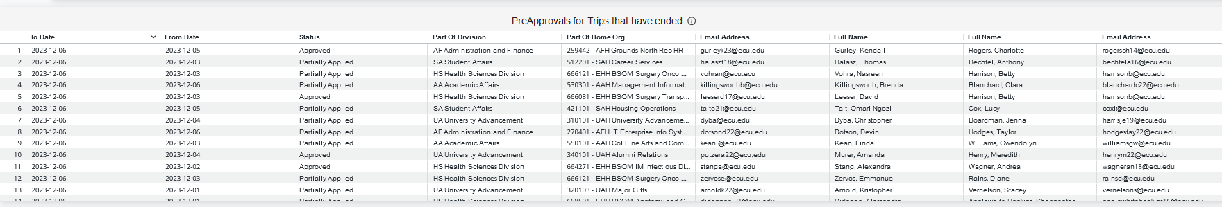
- Detail Analysis: This report lists all transactions (exported and non-exported) in current fiscal year.
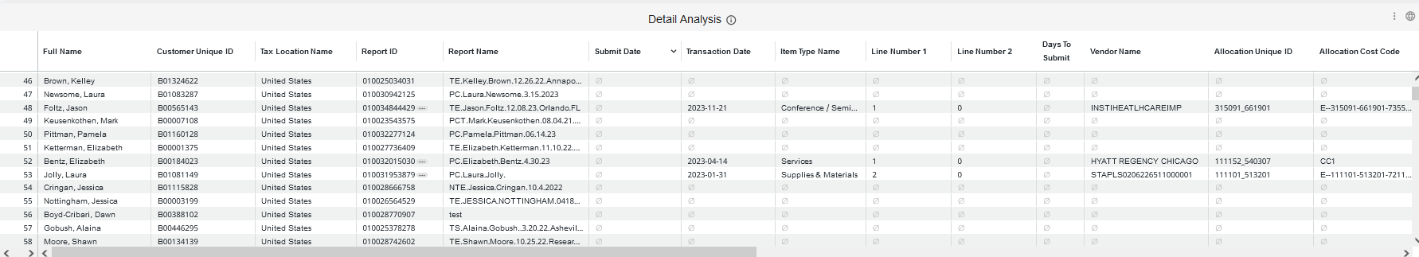
- Where’s My Report: This report shows all reports still in Chrome River, not yet exported to Banner.
