Fixed Rate Tuition Program
Frequently Asked Questions (FAQ)

What is the Fixed Tuition Program?
Beginning with the 2016/2017 academic year, each University of North Carolina (UNC) constituent institution implemented the Fixed Tuition Program as required by North Carolina General Statute §116-143.9 and UNC GA Regulation 1000.1.7[R].

What are the eligibility requirements to receive the Fixed Rate Tuition Program reduction?
First-time resident students seeking a baccalaureate degree in a four-year program will be eligible for 8 consecutive academic semesters (not including summer sessions).
Tuition rates for other currently enrolled resident undergraduates and eligible resident undergraduate transfer students will be fixed for an appropriate number of consecutive semesters, (not including summer sessions).
Transfer resident undergraduate students will receive fixed tuition for a prorated time period, based on credits accumulated at the transferring institution(s). Students transferring between UNC institutions, but maintaining continuous enrollment will be subject to the transfer student policy. For questions related to transferable undergraduate credits, please contact the Registrar’s Office at regis@ecu.edu

The following categories of students are not eligible for the Fixed Tuition Program: continuing education students; students currently enrolled in a cooperative innovative high school/early college, consortium, or dual-enrollment program; second degree seeking students; readmits who are not granted an appeal; non-degree seeking students; UNC Online, World Language; non-resident students; and graduate and professional students.

What if I don’t finish my baccalaureate program by the expiration date for my fixed tuition period?

At the end of the fixed tuition period, the cost of tuition for any additional academic semesters will be assessed at the current tuition rate for the next registered semester.

How do I know what my tuition rate is?
Each eligible student will be assigned a cohort by the Registrar’s Office that corresponds to their eligibility period. The tuition and fee schedule will display all tuition and fee charges for the current academic year. Eligible students that have a FXT1617 cohort will have a corresponding tuition credit amount below the current tuition rate. The billed tuition and the tuition credit added together will reflect the fixed tuition rate as determined by the assigned cohort (see sample billing statement below).
Please note: Eligible first-year students (i.e, Cohort FXT1718), will see the current tuition rate without a tuition credit.

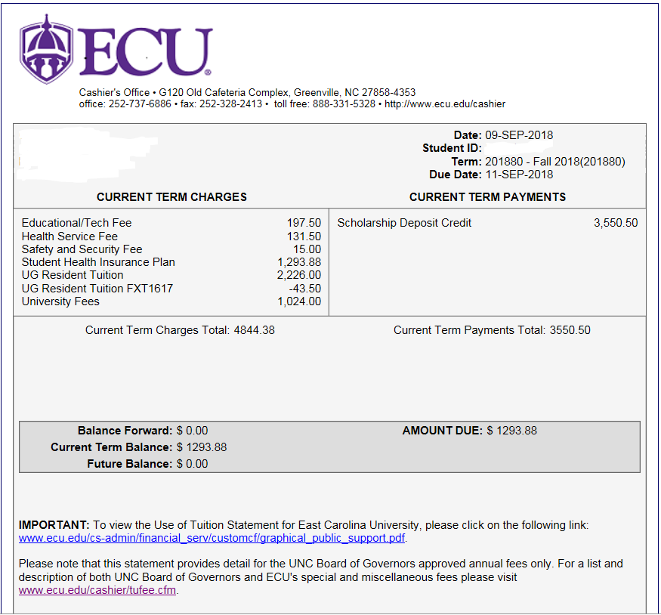

What is a cohort and how do I know which one I am assigned to?
For the purposes of fixed rate tuition, students will be assigned an identifier (cohort) based on their year of entrance to East Carolina University. Incoming freshmen undergraduate resident students will be assigned a cohort within the first 30 days of class. Undergraduate resident students who began matriculation in the 2016-2017 academic year have been assigned a cohort by the Registrar’s Office.
Students may find their assigned cohort by logging into their student account via Pirate Port and clicking on the Fixed Tuition Information link.

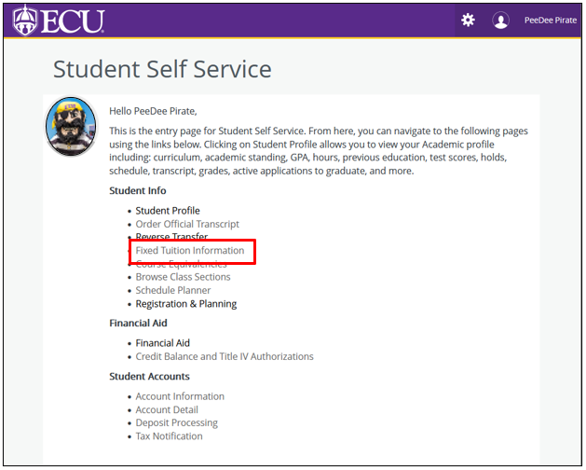
See Your Assigned Fixed Tuition Cohort Rate Here:
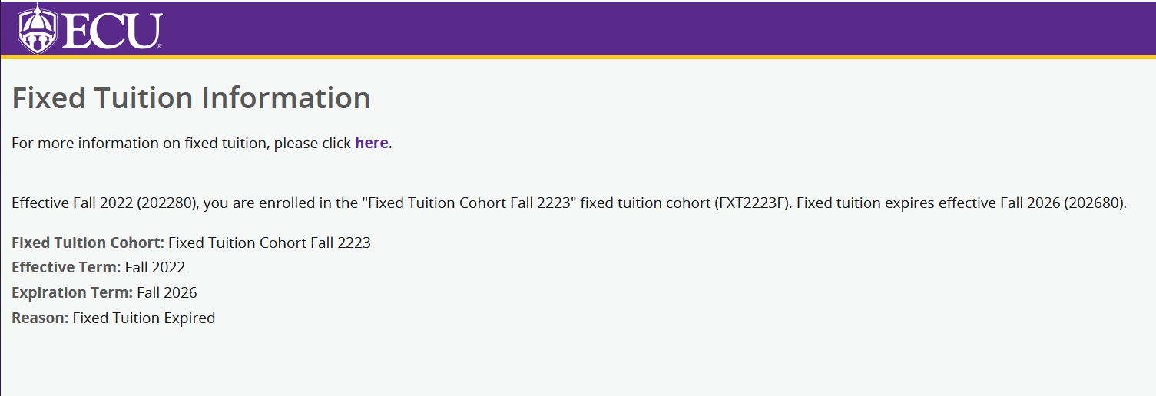
If you have not yet been assigned a Fixed Tuition Cohort:

What costs are covered under the Fixed Rate Tuition Program?
The program applies to a student’s tuition costs only. All fees are subject to change each academic year.

How is continuous enrollment defined?
Continuous enrollment is defined as a student being consecutively enrolled at the same higher education institution in the fall and spring semesters in courses creditable toward a baccalaureate degree. For purposes of the fixed tuition benefit, summer sessions are not considered part of the fixed tuition time period.

How do I appeal the loss of my Fixed Tuition Benefit?
Students who have interrupted continuous enrollment may petition for a waiver to retain initial fixed tuition under the following conditions: (1) military service obligation, (2) serious medical debilitation or (3) short-term or long-term disability. Waivers can be found at https://financialservices.ecu.edu/refund-and-withdrawal-policy/ and click on the Tuition Refunds Appeal Committee Standard Operating Procedures link.
For questions related to bills and tuition rates, please contact the Cashier’s Office, Monday – Friday, 8:00am – 5:00pm EST at 252-737-6886. You can also send an email to Cashier@ecu.edu. Students and parents are welcome to visit the Cashier’s Office located in Room G120, Old Cafeteria Complex on the ECU campus.
For questions related to cohorts, please contact the Registrar’s Office, Monday – Friday, 8:00am – 5:00pm EST at 252-328-6524. You can also send an email to Regis@ecu.edu. Students and parents are welcome to visit the Registrar’s Office located at 207 E. 5th Street, Greenville, NC 27858.
For questions related to residency status, please visit www.ncresidency.org. Information can also be found by clicking on the student link at https://registrar.ecu.edu/residency/

