CHROME RIVER QUICK GUIDE – CREATING A PRE-APPROVAL REPORT

- Click the + Create button on the Navigation Bar of the Pre-Approval Banner.
- 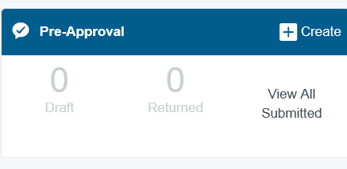

- Complete the pre-approval report header with the following:
  - Report Name – Use Standard Naming Conventions. See Naming Convention guide. Based on Report Type.
  - Start Date – Month of Blanket Starts
  - End Date – Month when Blanket Ends
  - Number of Days – This field will populate automatically based on dates entered
  - Business Purpose – Blanket Travel for employee’s name for “Month-Month”
  - Report Type Travel – Blanket
  - Travel Type select In-State
  - Excess Lodging – Select No
  - Cash Advance -N/A on Blanket travel
  - Additional Destination N/A
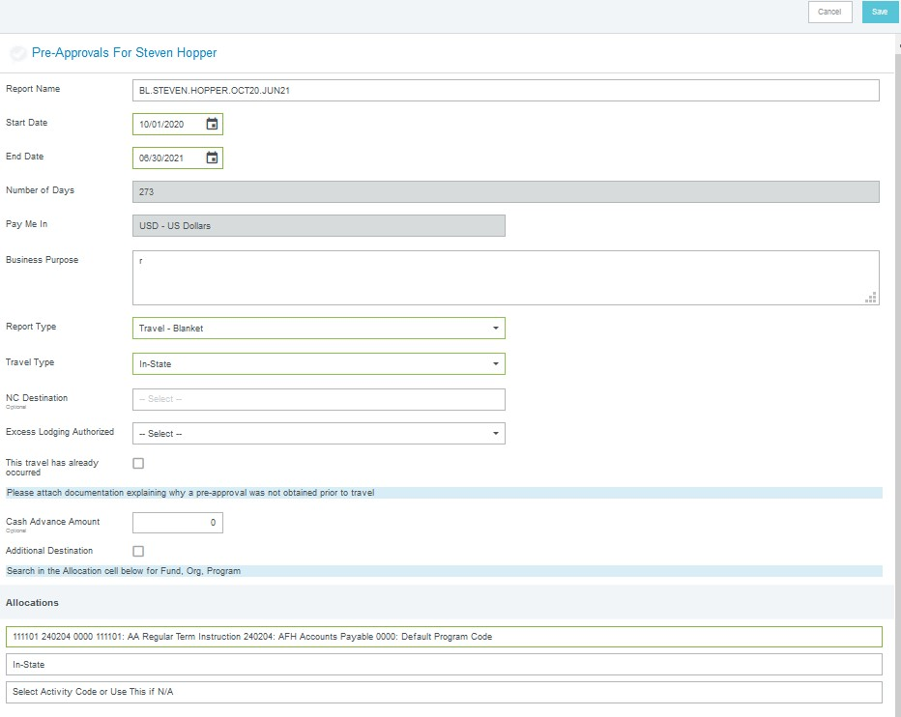
  - FOAP (Allocation) – Select the FOAP(s) where the spending will be charged. To add more than one index, click + Add Allocation. (Note that for pre-approval reports, the FOAP is only specified on the header, not on the individual expenses on the report.)
After the report header has been fully completed, click
Save in the upper right corner to continue.
- Select Ground Transportation expense to add to the pre-approval report from the expense tile mosaic to the right. Only authorized Expense types to be added to Blanket are Mileage, Parking, Tolls, and Fuel Personal Car.
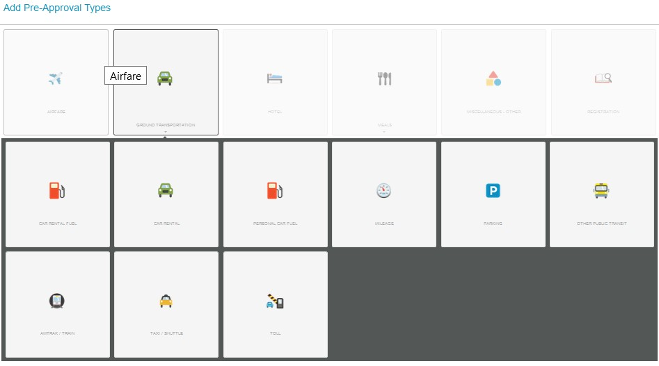
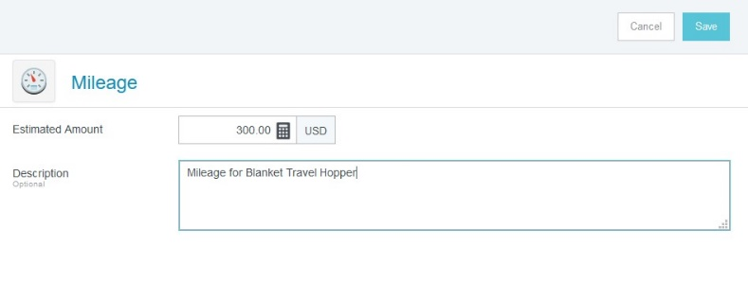
- Complete the expense tile form and click Save in the upper right corner to continue.
The expense will be added to your pre-approval report and visible on the report summary to the left. The expense tile mosaics will appear again on the right.
5. Once finished adding all expenses to preapproval report, click the green Submit Button at bottom of the report summary.

6. A submit confirmation will appear at the top right corner. Select Cancel to return to the report and make any changes. Select Submit to submit the pre-approval.

